This card was produced using the
Mendlesham Computer Club Christmas card template

Happy Christmas

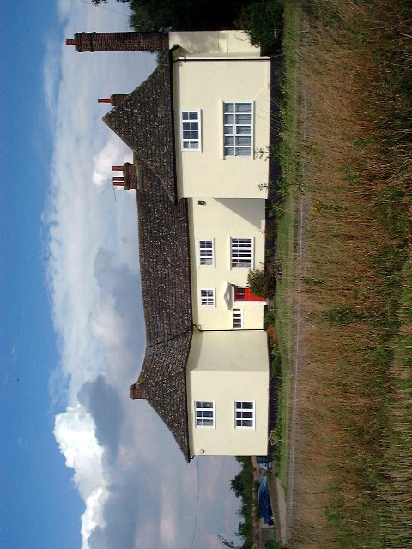

Wishing you a very
Happy Christmas 2023
From
Giles and Sonia

